KHAN INSTITUTE OF COMPUTER SCIENCE
AND INFORMATION TECHNOLOGY

COMPUTER SCIENCE DEPARTMENT

Advanced Visual Programming (Lab)

BSCS VI _ A

Submitted by:
Jamila Ansar

Reg# No.
232201013

Submitted to:
Sir Uzair Hassan

Assignment No.1

March,29,2026

AI Chatbot (Report)

1. Project Introduction
Problem Statement: Traditional software applications cannot understand or respond to natural language queries. Users are required to navigate complex menus or search for information manually. There is a need for an intelligent, conversational interface that understands human language and provides instant, relevant responses.
Objective: To develop an AI-powered Chatbot desktop application using C# and Windows Forms that integrates with the Google Gemini API, enabling users to have intelligent conversations and receive AI-generated responses in real time.
2. System Design
- Architecture Diagram
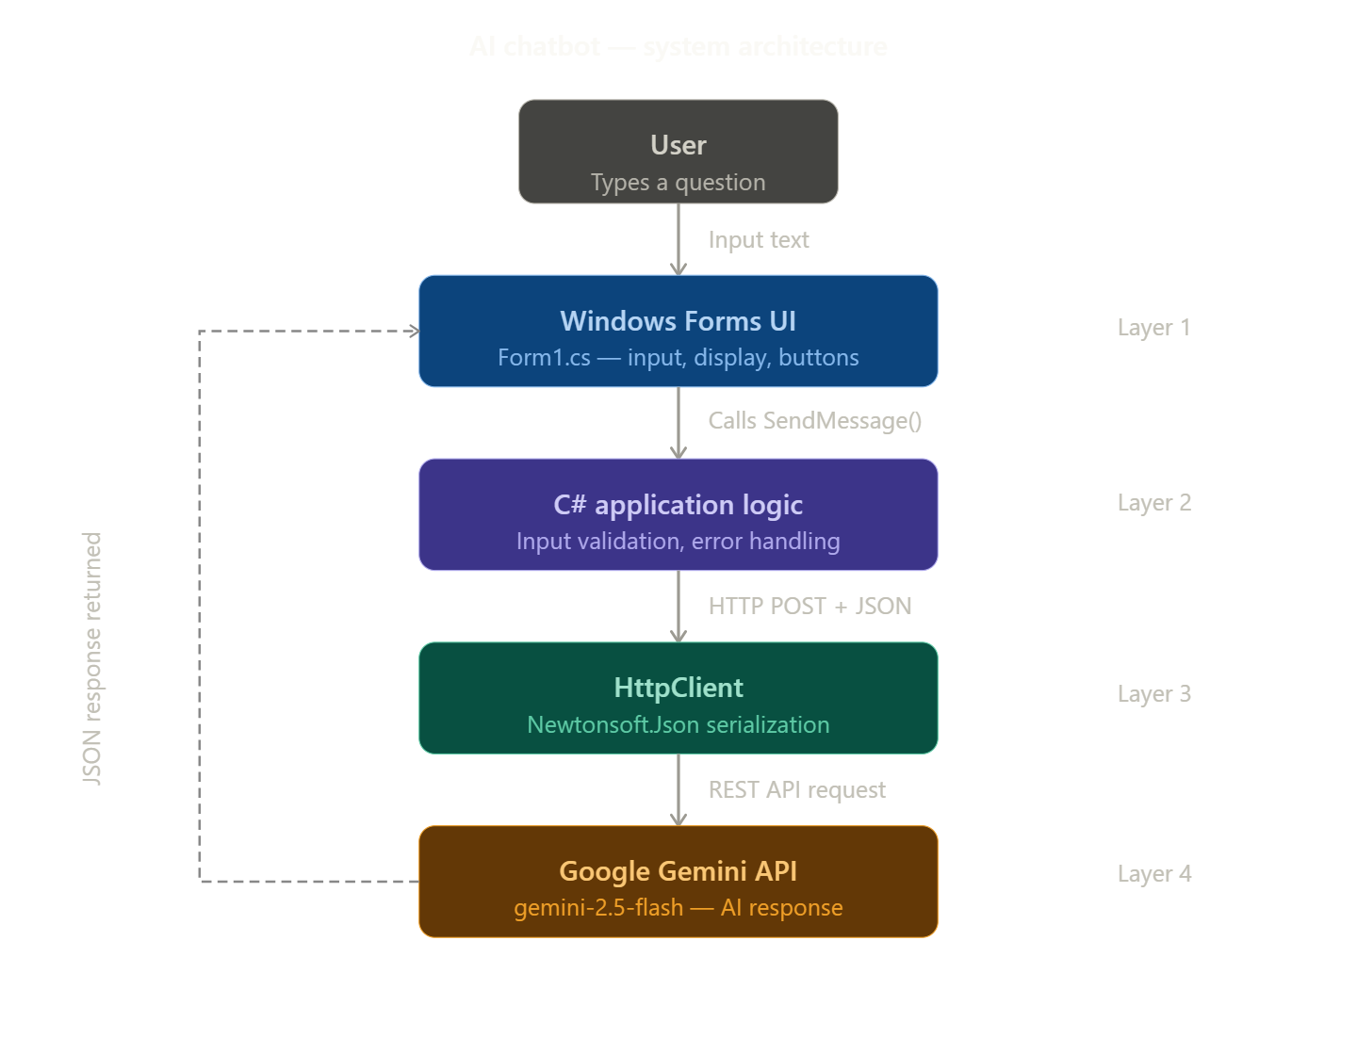

- Workflow Diagram
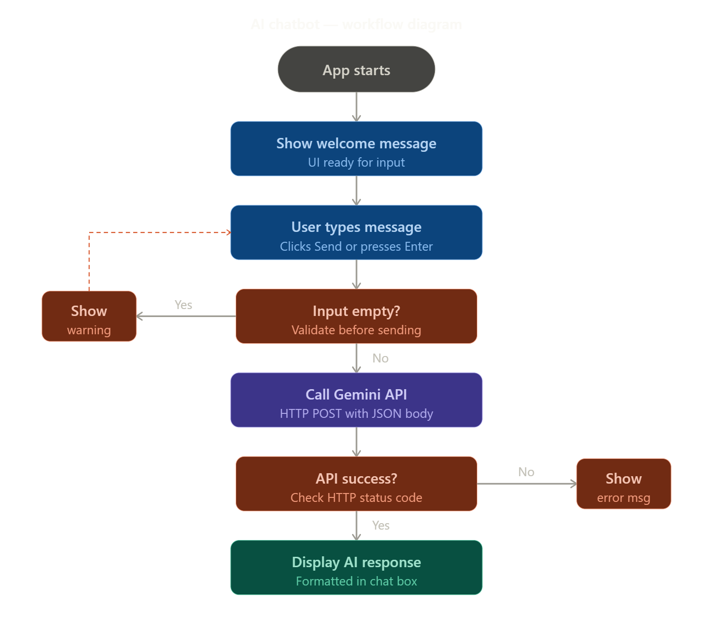
The application follows a 4-layer architecture:
The user interacts with the Windows Forms UI (Form1.cs). When a message is sent, the C# application logic validates the input and calls the CallGeminiAPI() method. The HttpClient serializes the request to JSON using Newtonsoft.Json and sends an HTTP POST request to the Google Gemini REST API. The API returns a JSON response which is parsed and displayed in the chat box with Markdown formatting rendered as rich text.
3. Tools & Technologies
Tools | Version/detail
.Net Framework | 4.7.2
Language | C#
IDE | Visual Studio 2026
UI Framework | Windows Forms
AI API | Google gemini (2.5 flash latest)
HTTP Library | System.Net.Http
Json Library | Newtonsoft.Json
Containerization | Docker
4. Code Snippets
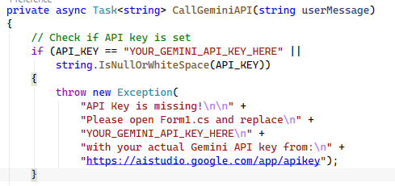
Builds a JSON request body matching Gemini API format, sends it via HTTP POST asynchronously, and returns the text response.

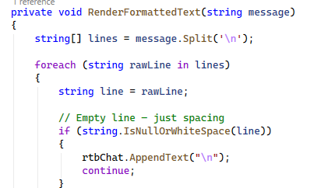
Splits the AI response into lines and applies rich text formatting based on Markdown syntax like ###, **bold**, and * bullet.
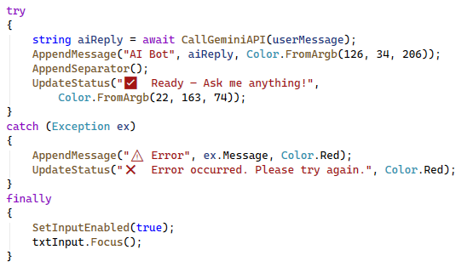
Uses try-catch-finally to handle API errors gracefully, display error messages to the user, and always re-enable the input controls.

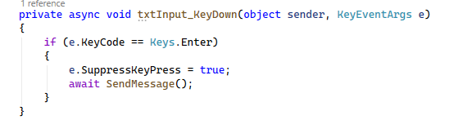
Captures the Enter key event on the text input box and triggers the send message function, improving user experience.
5. Application Preview
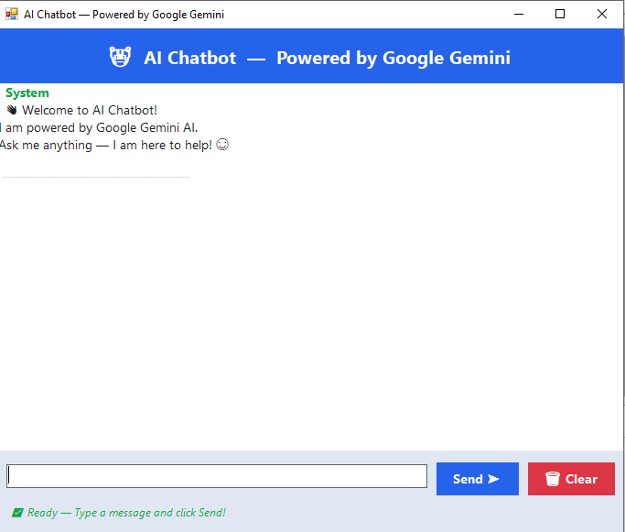
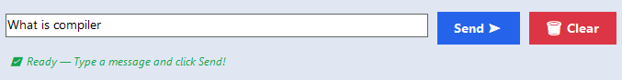
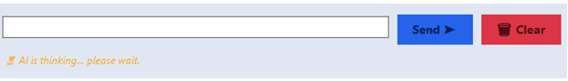

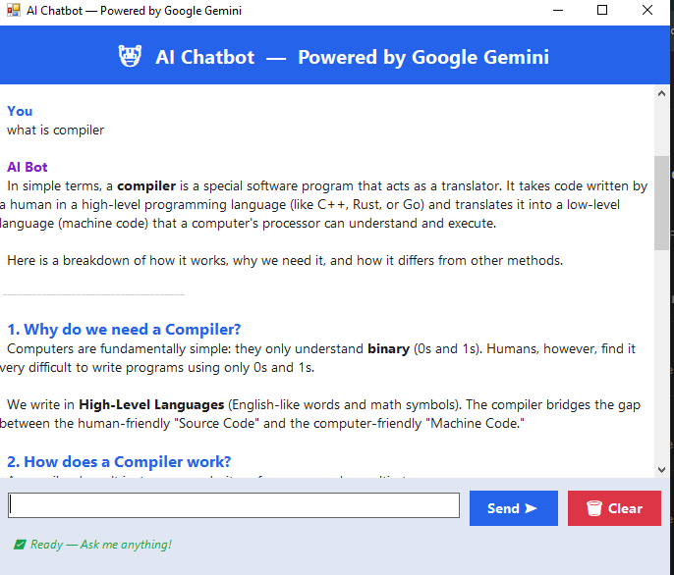
6. Testing
Test # | Input | Expected Output | Actual Output
1 | "What is AI?" | Detailed explanation | AI response displayed
2 | Empty input | Warning popup | "Please type a message" popup
3 | "Explain machine learning" | Formatted bullet points | Bullets and headings shown
4 | "Write a Python loop" | Code snippet | Code in red monospace font
5 | No internet connection | Error message | Error displayed in red

7. Results & Discussion
What Worked Well:
- The Gemini API integration works reliably and returns intelligent responses
- Markdown formatting renders properly with headings, bullets, and bold text
- Error handling correctly catches and displays API errors
- The Enter key shortcut improves usability
- The auto-retry logic handles temporary server overloads
Limitations:
- Requires an active internet connection at all times
- API has daily quota limits on the free tier
- Chat history is not saved when the application is closed
- No support for images or file attachments

8. Future Improvements
• Add chat history saving to a local database (SQLite)
• Implement voice input using Windows Speech Recognition
• Add multi-language support
• Create a dark/light theme toggle
• Add conversation context (send previous messages for follow-up questions)
• Export chat history to PDF or text file

Part 3: Docker Requirements
- Create a Docker File:
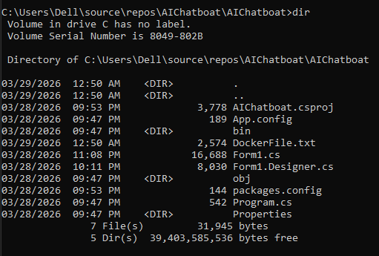

- Base Image:
mcr.microsoft.com/dotnet/framework/sdk:4.8 Used because our application targets .NET Framework 4.7.2, which requires the Windows-based .NET Framework SDK image.
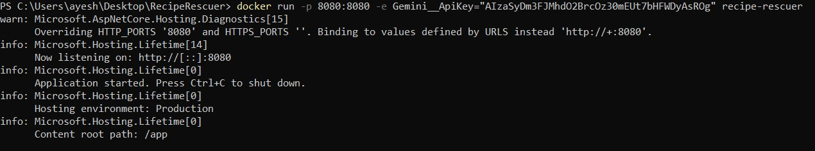
- Build Process:
The COPY. command copies all project files into the container. nuget restore downloads all NuGet packages including Newtonsoft.Json. msbuild compiles the project in Release configuration.
- Run Command:
dotnet run starts the compiled application inside the container.
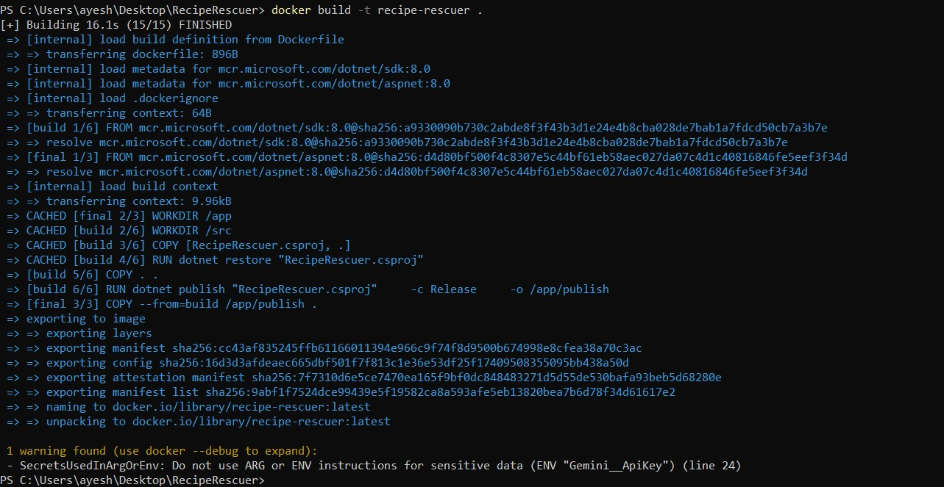

Conclusion
This project successfully demonstrates the development of an AI-powered Chatbot using C# Windows Forms integrated with Google Gemini API. The application fulfills all requirements including a functional UI, AI integration, input validation, formatted responses, and error handling. Docker containerization and GitHub submission requirements are also completed. Overall this project provides a practical demonstration of how AI APIs can be integrated into real-world .NET desktop applications.

References
- Google Gemini API Documentation — https://ai.google.dev/docs
- Google AI Studio — https://aistudio.google.com/app/apikey
- Microsoft .NET Documentation — https://docs.microsoft.com/en-us/dotnet
- Windows Forms Documentation — https://docs.microsoft.com/en-us/dotnet/desktop/winforms
- Newtonsoft.Json Documentation — https://www.newtonsoft.com/json
- Docker Documentation — https://docs.docker.com
- GitHub Documentation — https://docs.github.com

